INTRODUCTION, WELCOME AND THANKS
Welcome to Christchurch Hitchin. Whether you are a long standing member of this congregation, have stumbled across us on Youtube or are watching from some far and distant land, you are welcome. My name is Rachel Burgin and I will be taking the service this morning.
I am so grateful for the team who are participating in this service and working so hard behind the scenes to put everything together. To Tony Edmonds beavering away on the technology ensuring this service actually goes out. To Mandy Pye who has been in correspondence with me or weeks. To Paul and Briony Arnold who have pulled together the music and worship, for Cath Edmonds who will be delivering our bible reading and to my husband Paul Burgin who will be leading us in prayer.
Let us pray:
Opening Prayer
Father God, creator of heaven and earth,
God of Abraham, Isaac, and Jacob, God of Israel,
God and Father of our Lord and Savior Jesus Christ,
True and Living God who is Father, Son, and Holy Spirit,
Be with us in this service, speak to our hearts and empower us to do Your will in our lives.
AMEN
Let us have a moment of silence where we reflect on the events of this week both in our own lives and in the lives of our nation and the world. To the people we have encountered, the conversations we have had, the moments of joy and sadness, the words of kindness we have shared and perhaps those words that have not been so kind……
……………………………………………………………………………………..
Prayer of Confession
Gracious God, our sins are too heavy to carry, too real to hide, and too deep to undo. Forgive what our lips tremble to name, what our hearts can no longer bear, and what has become for us a consuming fire of judgment. Set us free from a past that we cannot change; open to us a future in which we can be changed; and grant us grace to grow more and more in your likeness and image, through Jesus Christ, the light of the world. Amen.
Our first hymn articulates the power of faith to bring great change in our own lives and the world. The chorus tells that we are children of the promise – and today we will be learning what that promise is, how all Christian believers are inheritors of that promise and the implications of those promises for our lives.
HYMN
By faith we see the hand of God (MP1262)
https://www.youtube.com/watch?v=jNIx__JGLGs
By faith we see the hand of God
In the light of creation's grand design
In the lives of those who prove His faithfulness
Who walk by faith and not by sight

By faith our fathers roamed the earth
With the power of His promise in their hearts
Of a holy city built by God's own hand
A place where peace and justice reign

We will stand as children of the promise
We will fix our eyes on Him our soul's reward
Till the race is finished and the work is done
We'll walk by faith and not by sight

By faith the prophets saw a day
When the longed-for Messiah would appear
With the power to break the chains of sin and death
And rise triumphant from the grave

By faith the church was called to go
In the power of the Spirit to the lost
To deliver captives and to preach good news
In every corner of the earth

We will stand as children of the promise
We will fix our eyes on Him our soul's reward
Till the race is finished and the work is done
We'll walk by faith and not by sight

By faith this mountain shall be moved
And the power of the gospel shall prevail
For we know in Christ all things are possible
For all who call upon His name

Our bible reading today will be read by Cath Edmonds.
Reading Genesis 25: 19-34
The Birth and Youth of Esau and Jacob
These are the descendants of Isaac, Abraham’s son: Abraham was the father of Isaac, and Isaac was forty years old when he married Rebekah, daughter of Bethuel the Aramean of Paddan-aram, sister of Laban the Aramean. Isaac prayed to the Lord for his wife, because she was barren; and the Lord granted his prayer, and his wife Rebekah conceived. The children struggled together within her; and she said, ‘If it is to be this way, why do I live?’ So she went to inquire of the Lord. And the Lord said to her,
‘Two nations are in your womb,
and two peoples born of you shall be divided;
one shall be stronger than the other,
the elder shall serve the younger.’
When her time to give birth was at hand, there were twins in her womb. The first came out red, all his body like a hairy mantle; so they named him Esau. Afterwards his brother came out, with his hand gripping Esau’s heel; so he was named Jacob. Isaac was sixty years old when she bore them.
When the boys grew up, Esau was a skilful hunter, a man of the field, while Jacob was a quiet man, living in tents. Isaac loved Esau, because he was fond of game; but Rebekah loved Jacob.
Esau Sells His Birthright
Once when Jacob was cooking a stew, Esau came in from the field, and he was famished. Esau said to Jacob, ‘Let me eat some of that red stuff, for I am famished!’ (Therefore he was called Edom.) Jacob said, ‘First sell me your birthright.’ Esau said, ‘I am about to die; of what use is a birthright to me?’ Jacob said, ‘Swear to me first.’ So he swore to him, and sold his birthright to Jacob. Then Jacob gave Esau bread and lentil stew, and he ate and drank, and rose and went his way. Thus Esau despised his birthright.
Sermon
Our reading today tells the story of two brothers who fell out. It comes from the first book of the bible – Genesis. Now the book of Genesis is split into two key sections: the first is chapters 1-11. To summarise this section of the bible as concisely as I can: God made the world and God made humans (Adam and Eve) to be in relationship with Him and to be stewards of His creation. But sadly humans broke that relationship – and for generation after generation – they rebelled against their Creator in an ever decreasing cycle of immorality, violence, idolatry and murder. This section ends with a flood which was God’s attempt to start again from scratch, saving only one family – that of Noah – also described as the “New Adam”. Sadly this does not solve the problem of rebellious humanity or rebuild the relationship between us and God. The story of the rest of the bible is God’s relentless pursuit of us to rebuild our relationship with Him.
The key to God’s strategy is at the heart of the remaining 38 chapters of Genesis. These chapters tell the story of an incredibly dysfunctional family! You see God promised a man named Abraham (Abram) that he would be built into a great nation, so that all the nations of the earth would be blessed. Now, both Matthew and Luke’s gospel contain genealogies that provide crucial evidence that Jesus is a direct descendent of Abraham – and it is, of course, through Jesus that the broken relationship between God and humanity is finally and completely restored.
But Abraham’s family is plagued with infertility – both his wife – and his daughter-in-law struggled to conceive. Now, this seemed to put at risk God’s promises to Abraham. How could he become a great nation if he could have neither children nor grandchildren? But, of course nothing can thwart the purposes of God. Abraham didn’t believe that so slept with his servant girl Hagar who gave birth to Ishmael.- and this led to one layer of the family’s dysfunction. But God promised to make Abraham’s descendants as numerous as the stars in the sky! And father of many nations. His wife eventually gave birth to Isaac. Abraham’s trust in God must have grown over time, because later he proved willing to sacrifice his son Isaac on Mount Moriah, though God relented.
And so we come to the protagonists in our passage today: Isaac, Jacob and Esau. The key context is that this is a family who carried with it a priceless birthright. They were to be a great nation, many nations, more numerous than the stars in the sky. In short, Isaac had one job: to pass that birthright onto the next generation. And any child growing up in this family had a duty to understand this. To listen to the lessons their parents taught them, the bedtime stories, the stories around the campfire.
I know the stories my parents have told me about their childhood – as well as the stories that have been passed from one generation to another. Dad, who is from a West Cumberland coal mining family, tells me that his first political memory was overhearing his parents and grandparents in the kitchen discuss how much they hated Winston Churchill for his use of troops to break miner’s strikes – and this is something that I’ve been reminded of during recent debates over statues!
And he also used to tell me that he was the oldest son of the oldest son going back 7 generations – and we would frequently ponder whether we were heirs of some great inheritance – which was, of course absurd given we were a family of miners and farm labourers. But we did come across a castle once. My maiden name is Stalker and there’s a castle between Oban and Fort William called Castle Stalker.

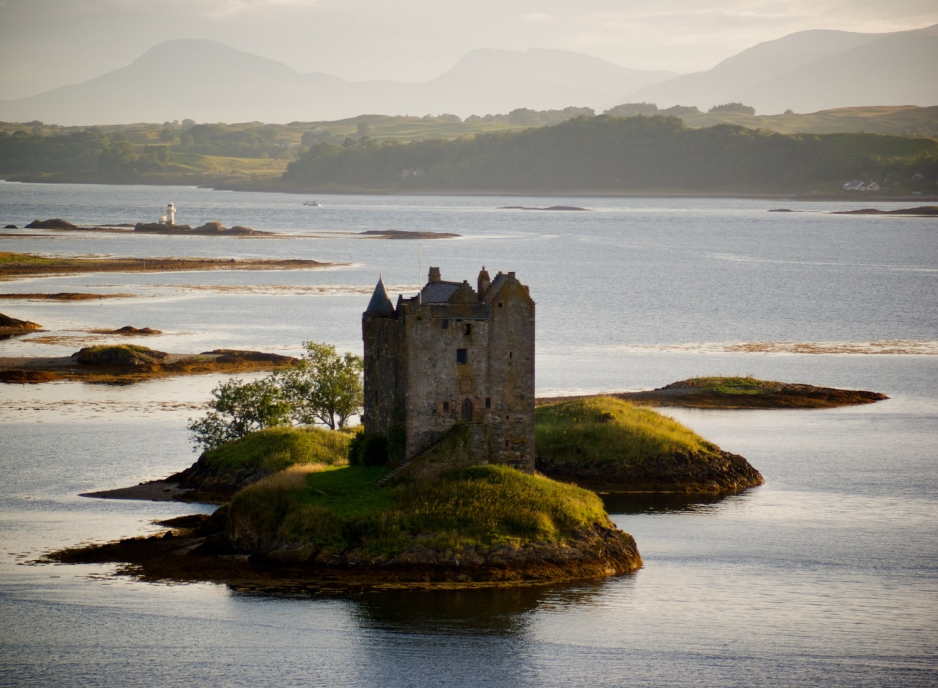

Various relatives had visited over the years and sent postcards. We’d ask ourselves whether this was our long lost inheritance! Of course, it wasn’t as it had been fought over between the Campbell’s and the Stuarts for centuries and was only called Castle Stalker because of the island it was on.
Why do I labour this point? Because at first glance, this story of Jacob and Esau seems the wrong way round. How did Jacob end up the good guy when he stole his brother’s birthright? And how did Esau end up the villain when he was simply the victim of a robbery? One answer is given in the New Testament – in the book of Hebrews:
“16 See that no one is sexually immoral, or is godless like Esau, who for a single meal sold his inheritance rights as the oldest son”
Esau is the villain here because he was the one who sold his birthright for a single meal. Now, the King James Bible calls this meal “sod pottage” which kind of sounds like mud pie – and was apparently that grim. In fact, this is one of those occasions where the bible helped to shape the English language. Because “sod pottage” came to mean “something worthless that is traded for something priceless. And that is exactly what happened here. The Message version of the bible puts it this way “That's how Esau shrugged off his rights as the firstborn.” And I think “shrugged off” nails it.
But this was no ordinary inheritance – not even a castle or a palace – but a key role in God’s plan to rebuild the broken relationship with humanity. In short, Esau’s rebellion put in jeopardy the entire purposes of God.
This story is played out two chapters later when Esau seeks his father’s blessing only to be told by Isaac:
“Your dwelling will be
away from the earth’s richness,
away from the dew of heaven above.
40 You will live by the sword
and you will serve your brother.
But when you grow restless,
you will throw his yoke
from off your neck.”

The bible says Esau held a grudge against Jacob. “The days of mourning for my father are near; then I will kill my brother Jacob.” Jacob hears of this and flees the country. And despite some reconciliation at the end of their lives, this starts family resentment that would pass from generation to generation. Until it grows into an enmity between nations. Jacob’s descendants would become the Israelites – the 12 tribes of Israel. Esau’s descendants would become known as the Edomites. Throughout the whole narrative of the Old Testament, we see these peoples at war with one another – and prophecies preached against the Edomites.

This is set out most clearly in an obscure Old Testament book called Obadiah. Take a look at this.

https://www.youtube.com/watch?v=i4ogCrEoG5s&t=1s

So there we have it: an utterly dysfunctional family that turned into warring nations – but that God was still able to use to accomplish his purposes!

Now what this video doesn’t mention is that perhaps the most famous Edomite of all was King Herod the Great. He was the king who killed all the infants under 2 in Bethlehem in an attempt to kill Jesus. The king who felt his birthright usurped by King Jesus who was a descendant of Jacob. How apt.

That King Jesus was the fulfilment of the promises made to Abraham. That through him all nations of the world would be blessed. He was the birthright that Esau had sold for some sod pottage. He was God’s solution to the broken relationship with humanity. That through Jesus’s final work on the cross, taking the sins and the brokenness of the whole world, we have access to our Heavenly Father. Our relationship with our Creator is restored.

And in Jesus we see God’s heart for our own restored relationships. Who taught us to love our enemies, who reached out to enemy people – to a Roman Centurioin, a Samaritan Woman and Tax Collectors. It is through Christ that old grudges and resentments – like between Jacob and Esau – and between the Israelites and the Edomites can be restored.

Now the New Testament is full of language alluding to inheritance and adoption. In short, as Christians, we are adopted into the family of God. In fact in Galatians we read that “those who have faith are children of Abraham.” And so we too are inheritors of this birthright. To be used in God’s purposes to restore the broken relationship with humanity. St Paul, writing to the church in Corinth clearly articulated the consequences for Christian believers.

Therefore, if anyone is in Christ, the new creation has come: The old has gone, the new is here! 18 All this is from God, who reconciled us to himself through Christ and gave us the ministry of reconciliation: 19 that God was reconciling the world to himself in Christ, not counting people’s sins against them. And he has committed to us the message of reconciliation. 20 We are therefore Christ’s ambassadors, as though God were making his appeal through us. We implore you on Christ’s behalf: Be reconciled to God.

Friends our birthright is a ministry of reconciliation. We are to be reconciled to God, we are to reconcile others to God – and I believe we should be reconciled to others. Whether we see ourselves as a Jacob or an Esau, we should be the one building bridges. In our broken and divided world we should be the peacemakers.

This is me outside First Derry Presbyterian Church in Northern ireland. It has been a place of worship for my maternal family for centuries.

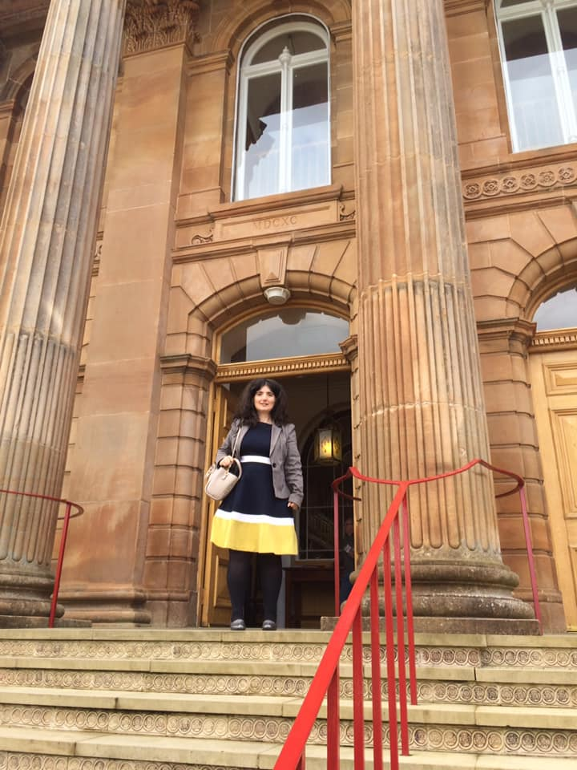

But there is another photo of this building which is sadly protected by copyright. It is a photo of former Deputy First Minister, Martin McGuinness shaking hands with the church minister, Rev David Latimer. I have to confess that when I first saw this picture, my heart exploded with a cacophony of confused and conflicted emotions.

Let me explain. First Derry Church dates back to 1690 and was financed by Queen Mary as a gesture of gratitude for the courage of the Presbyterians during the Seige of Derry. It is an iconic landmark that abuts the city walls and overlooks the Catholic Bogside estate where, in 1972 Bloody Sunday took place. What ensued was nothing short of civil war – and this part of Derry was the epicentre of the Troubles. My parents married there in July 1972 in what they refer to darkly as a “shotgun wedding” because the IRA were shooting at the church from the city walls during the service. One of the ringleaders of the IRA in Derry at that time was Martin McGuinness.

The church struggled during the Troubles and eventually fell into disrepair. The Minister, Rev David Latimer approached the Nationalist-run City Council for funding for this historic landmark – and this approach was successful, more than £2 million. This photo was of Martin McGuinnesss at the church’s reopening. He was there along with the great and the good of the city as well as relatives of Bloody Sunday. He was at a church that 40 years earlier he had tried to destroy but was now there to celebrate its rebuilding. It was a moment of grace, of healing and reconciliation.

May we go out into this week to create our own moments of reconciliation. It is, after all, our birthright.

Let us have a moment of silence to reflect on the people who are in our life. The relationships that we have and for the places of brokenness. Let us reflect on what we can do to bring healing and reconciliation to those relationships and to our daly lives.

Perhaps you have been inspired to take political action for peace and reconciliation in our broken and divided world, through organisations such as the Fellowship of Reconciliation (https://for.org.uk/).

Whatever action we are inspired to take, may we take it.
…………………………………………………………………

Let us pray:
Lord, make me an instrument of your peace.
Where there is hatred, let me bring love.
Where there is offence, let me bring pardon.
Where there is discord, let me bring union.
Where there is error, let me bring truth.
Where there is doubt, let me bring faith.
Where there is despair, let me bring hope.
Where there is darkness, let me bring your light.
Where there is sadness, let me bring joy.
O Master, let me not seek as much
to be consoled as to console,
to be understood as to understand,
to be loved as to love,
for it is in giving that one receives,
it is in self-forgetting that one finds,
it is in pardoning that one is pardoned,
it is in dying that one is raised to eternal life.

Having shared a story about Londonderry, I felt it would be churlish not to sing a hymn to the tune of the Londonderry Air. This hymn is one about authentic love. And this here is a cherished gift from a friend that is also about love. The reason it is so cherished is that it was bought by a friend who would never for a moment describe herself as Christian but she actually went to the Christian bookshop in Letchworth to buy it for me. It sets out the characteristics of love in 1 Corinthians 13: that love is patient, kind, keeps no records of wrong. There are so many counterfeit forms of love in our world but none of them will bring peace and reconciliation.

HYMN
Let love be real, in giving and receiving (to the Londonderry Air) (StF 615)
https://www.youtube.com/watch?v=SkBAxZw5NxU

Let love be real, in giving and receiving, without the need to manage and to own;
a haven free from posing and pretending,
where every weakness may be safely known.
Give me your hand, along the desert pathway,
give me your love wherever we may go:
as God loves us, so let us love each other,
with no demands, just open hands and space to grow
.
Let love be real, not grasping or confining,
that strange embrace that holds yet sets us free;
that helps us face the risk of truly living,
and makes us brave to be what we might be.
Give me your strength when all my words are weakness,
give me your love in spite of all you know:
as God loves us, so let us love each other,
with no demands, just open hands and space to grow.

Let love be real, with no manipulation,
no secret wish to harness or control;
let us accept each other's incompleteness,
and share the joy of learning to be whole.
Give me your hope through dreams and disappointments,
give me your trust when all my failings show:
as God loves us, so let us love each other,
with no demands, just open hands and space to grow

I now hand over to Katherine Harris for our Christchurch Community Moment. This interview with Euan Gilfillan was recorded earlier in the week.

CHRISTCHURCH COMMUNITY MOMENT

PRAYERS – Paul Burgin

EUAN GILFILLAN
Heavenly Father, we pray for Euan and we thank you for your grace in his life and his service to the young people in church. We pray for him – and for all A’Level and GCSE students who are being graded on the basis of an incomplete school year. We pray for wisdom to all involved in the marking process: that it will be fair and that all students will get the grades that they deserve and will be able to continue their studies as they wish.

Lord we pray for the young people in our Church – and across the circuit who are not able to connect with the church or with each other. That they would know your presence in their lives and continue to walk in your ways.

In the name of Jesus, Amen.

A PRAYER OF RECONCILIATION
God of reconciliation and grace,
you promise us a world where all is new,
where love is born when hope is gone,
where broken relationships are restored to wholeness.
May we live as people who know your story of love,
and we have the vision to imagine what could be possible
if we dared to live this story.
God of abundant life,
may we be witnesses of love, hope and peace,
and co-creators of your life in the world. Amen

PRAYER FOR THE NHS
Our Lord, We thank you for the NHS and the many thousands of workers who make up our health service. We particularly pray at this time when frontline healthworkers and care home workers who have put themselves at risk of infection in order to provide care to others. Bless them and protect them in their work.
Amen.

PRAYERS FOR THOSE LIVING WITH DEBT
Lord we pray for those who have financially suffered due to the coronavirus: that you will show them some way to recover and that there will be help for them, and that they have peace, and where we have responsibilities in this area, show us where we can use them
In Jesus Name Amen.
PRAYER FOR THE GOVERNMENT
Heavenly Father,
We pray for our government – particularly at this difficult time for our nation. Give wisdom to all in authority that they will be led in the ways of justice and peace.
Lord we pray with regards to the US elections later this year, and closer to home with regards to the end of the Brexit talks as they are this December: that your will be done, that there will be an end to the polarisation taking place, that there is a development of mutual respect, and that financial security in this country will soon start to grow and not shrink
Amen

Rachel and Paul Burgin

Let us pray with the prayer that Jesus taught us.

THE LORD’S PRAYER
Our Father in heaven,
hallowed be your name,
your kingdom come,
your will be done,
on earth as in heaven.
Give us today our daily bread.
Forgive us our sins
as we forgive those who sin against us.
Lead us not into temptation
but deliver us from evil.
For the kingdom, the power,
and the glory are yours
now and forever. Amen.

CLOSING PRAYER
Go forth into the world in peace;
be of good courage;
hold fast that which is good;
render to no one evil for evil;
strengthen the fainthearted;
support the weak;
help the afflicted;
honour everyone;
love and serve the Lord,
rejoicing in the power of the Holy Spirit;
and the blessing of God almighty,
the Father, the Son, and the Holy Spirit,
be among you and remain with you always. Amen.

We are so glad you could join us this morning – albeit virtually.

We close with a hymn that I hope will encourage us to bring beauty into all the brokenness of our world this week. And as we do so, may we hold in our hearts the priceless inheritance we hold as children of Abraham. And with that, may we take seriously our ministry of reconciliation.

CLOSING HYMN
Beauty for Brokenness (MP806)
https://www.youtube.com/watch?v=3kVHKuldZyw

Beauty for brokenness
Hope for despair
Lord, in the suffering
This is our prayer
Bread for the children
Justice, joy, peace
Sunrise to sunset
Your kingdom increase!

Shelter for fragile lives
Cures for their ills
Work for the craftsman
Trade for their skills
Land for the dispossessed
Rights for the weak
Voices to plead the cause
Of those who can't speak

God of the poor
Friend of the weak
Give us compassion we pray
Melt our cold hearts
Let tears fall like rain
Come, change our love
From a spark to a flame

Refuge from cruel wars
Havens from fear
Cities for sanctuary
Freedoms to share
Peace to the killing-fields
Scorched earth to green
Christ for the bitterness
His cross for the pain

Rest for the ravaged earth
Oceans and streams
Plundered and poisoned
Our future, our dreams
Lord, end our madness
Carelessness, greed
Make us content with
The things that we need

God of the poor
Friend of the weak
Give us compassion we pray
Melt our cold hearts
Let tears fall like rain
Come, change our love
From a spark to a flame

Lighten our darkness
Breathe on this flame
Until your justice
Burns brightly again
Until the nations
Learn of your ways
Seek your salvation
And bring you their praise

